**Oracle Backup and Recovery Concepts – “Getting the House in Order”**

**Background:** Your database is ready to move from test or development into production. You must ensure to configure your database to reduce the chances of failure or data loss. The key steps covered in this lab is to ensure the Control files are multiplexed accordingly, online redo logs are also configured so they are multiplexed as well as the database being in ARCHIVELOG Mode.

**Note** Online Redo log groups are written to in a circular fashion i.e. they are overwritten. To ensure the database can recover from media failures for example, we must ensure the online redo log files are archived before they are overwritten. To this we must put the database in ARCHIVELOG Mode. The online redo logs that are archived are called **archive logs**.

**1.** Verify that you have two control files to ensure redundancy. We are going to add another in a new directory in case of disk failure. In a production environment, we would put this it in a directory on a separate physical disk.

**a)** Invoke Enterprise Manager and login as the SYS user in the SYSDBA role.

**b)** Select **Server**> **Storage** > **Control Files**.

Make a note of File directory paths and Control File names by taking a copy of same.

(use the Snipping Tool). Add the screen shot below.

Answer: 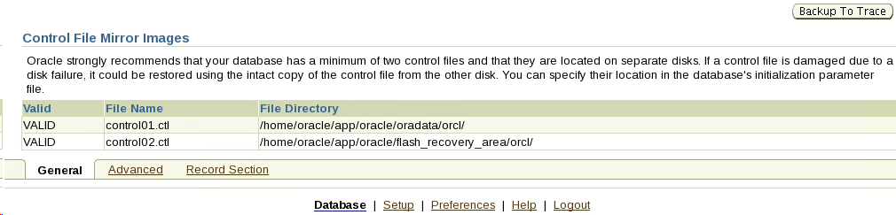

**c)** Let us look how would you add another control file if you needed to.

Adding a control file is a manual operation. To perform this, you must:

* Use the operating system to copy an existing control file to the location where you want your new file to be. In our case, we will create a new directory called controlfilebackup as follows: **/home/oracle/app/oracle/oradata/*orcl*/controlfilebackup.**
* Go to the desktop, there is a folder called Oeacle’s Home. Select this then got to **app/oracle/oradata/*orcl*/**
* Choose file from the drop down menu and then create folder. Create a new folder called controlfilebackup. Be careful of spelling here!
* Now take a copy of the Control01.ctl, which is just below in the ORCL folder, and put it into the path created above. Rename the file to Control03.ctl.
* Control03.ctl not Control02.ctl as this is already there. Check your first screen shot!
* Please follow these steps carefully as errors on this can cause issues later. Double check now that all the above is done correctly.

**NOTE: orcl is the name of the database instance we are using. In the real world we would put in the database name here so this path will change.**

What we would do now is to edit the CONTROL_FILES initialization parameter to point to the new control file. To this we must run an alter system command however we will not cover this today. It is sufficient that you have a backup of your control file.

Make a note of the paths for each control file and explain why having the backup is so important.

Answer:/home/oracle/app/oracle/oradata/orcl/controlfilebackup/control03.ctl. Reason for backup is because there may be an accident in the future leading to loss of the data and this is why backups are important to reduce that risk of data loss.

**2.** Check how many members each redo log group has. Ensure that there are at least two redo

log members in each group. In what directory or directories are the redo log files stored?

1. Select **Server**> **Storage** > **Redo Log Groups**, and note how many members are in the “# of Members” column. There should be two per group. Add Screen shot of what you have below:

Answer: 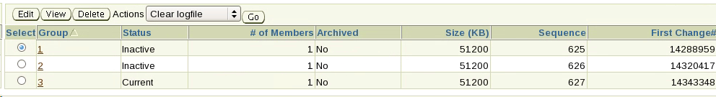

You can see that there are not two in each group so we will address this now.

Select the first group, and then click **Edit** to see the member file names. Note that one member is in directories under the oradata directory., Let’s add a new member to each group the Flash Recovery Area. Create a folder called **onlinelogs** in the path below:

/home/oracle/app/oracle/flash_recovery_area/orcl/onlinelogs

Starting with Group1 add a new member giving it a name REDO0102.log. Create it in

/home/oracle/app/oracle/flash_recovery_area/orcl/onlinelogs

**Note: 01 signifies Group 1 and 02 signifies the 2nd member of the group**

Make a note of the SQL that is generated

|  |
| --- |
| Answer: |

Add an additional log member to the remaining REDO Log Groups as similar to above. Supply

screen shot of this when completed below:

|  |
| --- |
| Screen shot: |

**[Note:** In a production database, you want to ensure that the two members are on different hard drives, preferably with different disk controllers, to minimize the risk of any single hardware failure destroying an entire log group].

**3.** Go to the REDO LOG Groups main screen. You notice that, for each log group, the Archived column has a value of **No**. This means that your database is not retaining copies of redo logs to use for database recovery, and in the event of a failure, you will lose all data since your last backup. You need to place your database in ARCHIVELOG mode, so that redo logs will be archived.

**a)** Create a new directory **/home/oracle/app/oracle/oradata/orcl/archive** as the destination for the redo log files we will archive.

**b)** In Enterprise Manager, select **Availability**>**Backup/Recovery>etup**>**Recovery Settings**.

**c)** In the **Media Recovery** region, select the **ARCHIVELOG Mode** check box.

**d)** Verify that Log Archive Filename Format contains %S, %R, and %T. (%t_%s_%r.dbf) Include screen shot below

|  |
| --- |
| creen shot:   |

You are now going to go to **Availability/Recovery Settings** to configure redundant archive log destinations—one to the Flash Recovery Area and the other to **/home/oracle/app/oracle/oradata/orcl/archive/**

Notice that the database is preconfigured to save archived logs to the Flash Recovery Area by default. Add an additional Archive Log Destination so that you will have redundant copies of your log files.

a) Click **Add Another Row** button and enter **/home/oracle/app/oracle/oradata/orcl/archive**/

The directory path should end with a slash.

**Note:** You must create the directory, if it does not already exist. You already did this in step (3).

**b)** Click **Show SQL** and make a note of the SQL that is generated below.

, review the statements, and then click **Return**.

|  |
| --- |
| Answer: |

1. Click **Apply**.
2. **When** prompted whether you want to restart the database now, click **Yes**.
3. Enter the credentials to restart the database

Host credentials are **oracle, oracle** and database credentials **are sys, oracle**.

and then click **OK**.

1. When asked to confirm, click **Yes** again.
2. Logout and login again.

Now that your database is in ARCHIVELOG mode, it will continually archive a copy of

each online redo log file before reusing it for additional redo data.

**Note:** Remember that this consumes space on the disk and that you must regularly back up older archive logs to some other storage.

1. You are going to artificially archive the online redo logs.Execute a SQL Command in SQL DEVELOPER that forces a log switch.

**ALTER SYSTEM SWITCH LOGFILE;**

Do this a number of times and include screen shot below

|  |
| --- |
| Screen Shot: |

1. Check that the archived logs have been generated. List their names here. You can see them if you go to **Server>Storage>Archive Logs.** Include a screen shot below:

|  |
| --- |
| Screen Shot: |

**Performing Database Backups Labs**

**Background:** Your database is ready to move from development and test into production. Many failures of the Oracle database can be traced to some sort of media failure, such as disk or controller failure. One key step in the recovery process is to ensure your Oracle database is backed up so that recovery is possible without loss of data. Let us set up a back-up regime.

**1.** Note the difference between a **backup set** and an **image copy** in Oracle

* A **backup set** contains data and archive log files packed in an Oracle proprietary format. Files must be extracted before use.
* **Image copies** are the equivalent of operating system file copies and can be used to restore operations immediately.

**2.** What is the destination of any disk backups that are done?

**a)** In Enterprise Manager, select **Availability**> **Backup/Recovery**>**Setup**> **Backup Settings**. Note the message under the Disk Backup Location that says the Fast Recovery Area (the folder is actually called the Flash_recovery_area) is the current disk backup location.

**3.** First we will test making a backup to disk, as a backup set, with OS username ***oracle*** and password ***oracle*** for Host Credentials.

**a)** Select **Backup Set** as your **Disk Backup Type**.

**b)** Scroll to the bottom and enter ***oracle*** and ***oracle*** for **Host Credentials Username** and **Password** for your server.

**c)** Click **Test Disk Backup**. Near the top on the right hand side!

**d)** When the test finishes, click **OK**.

Next we will step through a back up your entire database, without archived logs, while the database is open for user activity. This is known as an **online backup** or a **hot backup**. This backup should be the base for an incremental backup strategy.

To createa valid backup of a database without shutting it down there is a prerequisite*,* The database **must** be in ARCHIVELOG mode. Backups made with the database open but not in ARCHIVELOG mode cannot be used for recovery.

**a)** Select **Availability > Manage**>**Schedule Backup**.

**b)** Select **Whole Database** as the object to be backed up.

**c)** Enter ***oracle*** and ***oracle*** for **Host Credentials Username** and **Password** for your server.

**d)** Click **Schedule Customized Backup** button.

**e)** Select **Full Backup** for your Backup Type, and select the **Use as the base of an incremental backup strategy** check box.

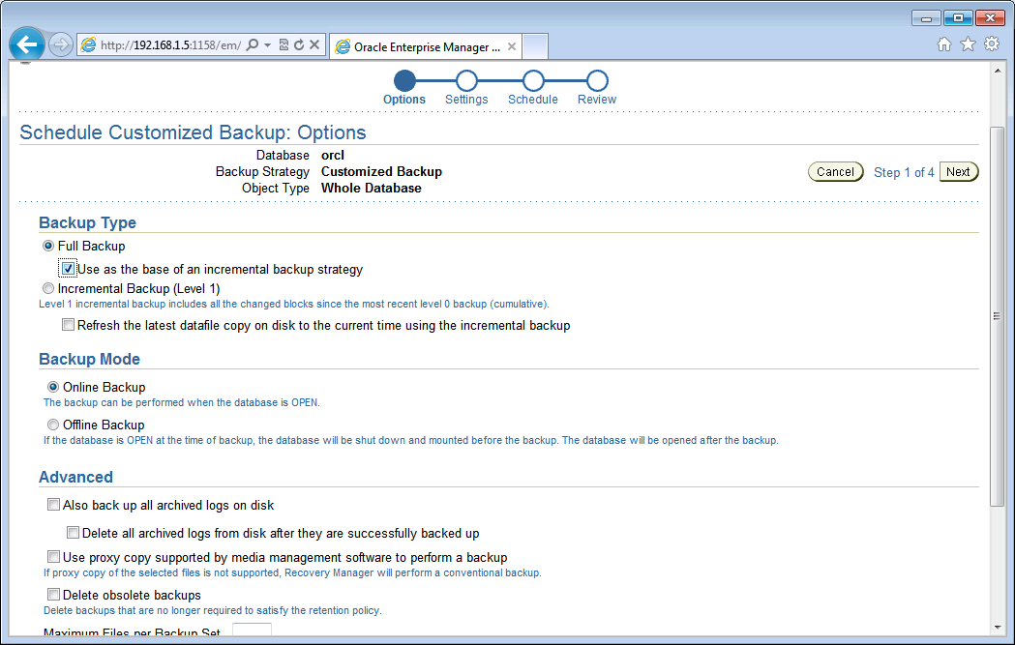

**f)** Select **Online Backup** as Backup Mode.

**g)** In the **Advanced** region, deselect the **Also backup all archived logs on disk** check

box, and then click **Next** to continue.

**h)** Select **Disk** for your backup location (notice that your Disk Backup Location is retained from step [2]). Click **Next** to continue.

**i)** Accept all the defaults on the Schedule page, and then click **Next** to continue.

**j)** Click **Submit Job** to perform the online database backup.

**k)** Click **View Job** to monitor the status of the backup job. This backup takes

no more than five minutes to complete. Include a screen shot of this screen.

|  |
| --- |
| Screen Shot: |

**5.** Schedule nightly disk-based incremental online backups for your whole database, without

archived logs. Schedule it for 11:00 p.m. The schedule should be in effect indefinitely.

**a)** In Enterprise Manager, select **Availability > Manage** >**Schedule Backup**.

**b)** Select **Whole Database** as the object to be backed up.

**c)** Enter ***oracle*** and ***oracle*** for **Host Credentials Username** and **Password** for your server, and then click **Schedule Customized Backup**.

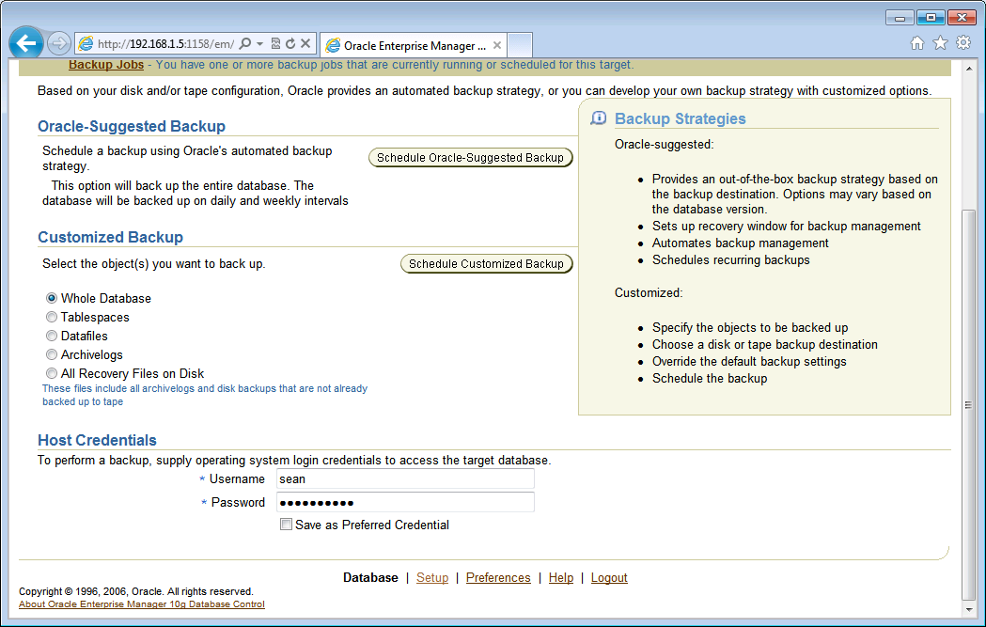

**d)** Select **Incremental Backup (Level 1)** for your Backup Type.

**e)** Select **Online Backup (HOT BACKUP)** as Backup Mode.

**f)** In the **Advanced** region, deselect the **Also backup all archived logs on disk** check box, and then click **Next** to continue.

**g)** Select **Disk** as your backup location, and then click **Next** to continue.

**h)** Change **Job Name** to Nightly_Backup and accept the default value for **Job**

**Description**.

**i)** Select **Repeating** in the **Schedule** region.

* Select By Days from the Frequency Type drop-down list, enter 1 the Repeat Every field
* Confirm that **indefinite** is selected as **Repeat Until**
* Accept today’s date and enter 11:00 p.m. for **Start Time**.
* Add the screen shot for this here

|  |
| --- |
| Screen Shot: |

Now click **Next**.

**l)** Click **Submit Job**, and then click **OK**.

**m)** Navigate to **Home**> **Related Links** > **Jobs ( bottom of the page)** to see the scheduled job in the **Job Activity** list.

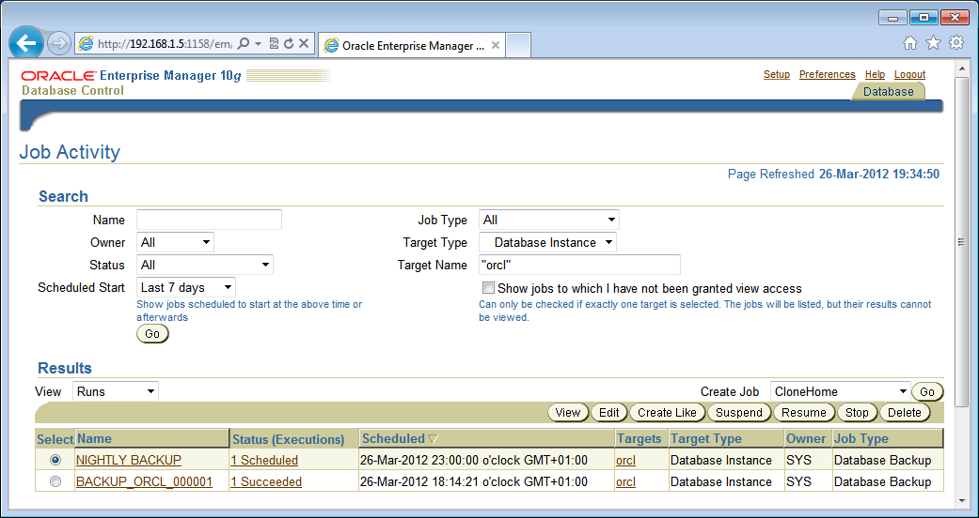

You now have a backup scheduled.